# PC Geeks Games

## Definition

**# Source**: **Windows ScreenShots From Site -> https://pcgeeks-games.com/ at [8/27/2025]**



**# Source**: **Chatgpt (GPT-5-Standard) at [8/27/2025]**

**PC Geeks Games** is an Arabic website that provides a large library of free PC games, focusing on **small-sized games** that are easy to download.  
The platform is designed for gamers who want lightweight games that can run on computers with limited specifications.

## Key Highlights

**# Source**: **Chatgpt (GPT-5-Standard) at [8/27/2025]**

* **Fast Downloads:** Direct and quick download links for games.
* **Variety of Games:** Includes action, adventure, strategy, and sports games.
* **Technical Support:** Offers help for game-related issues.
* **Regular Updates:** Frequently adds new games and updates existing ones.
* **User-Friendly Interface:** Simple website design for easy browsing.

## Summary Table

**# Source**: **Chatgpt (GPT-5-Standard) at [8/27/2025]**

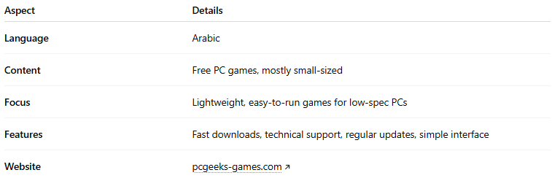

| **Aspect** | **Details** |
| --- | --- |
| **Language** | Arabic |
| **Content** | Free PC games, mostly small-sized |
| **Focus** | Lightweight, easy-to-run games for low-spec PCs |
| **Features** | Fast downloads, technical support, regular updates, simple interface |
| **Website** | [pcgeeks-games.com](https://pcgeeks-games.com/) |